# Lab1

# Object oriented concepts

1. **Object**



Objects can have different kinds of states and functions. They are created from a class.

1. **Class**

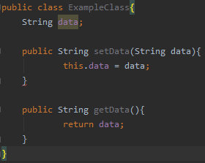

Classes are basically the blueprints for the individual objects. They contain different kinds of variables and behaviors for the objects.

1. **Instantiation of an object**



Objects are instantiated when the ‘new’ keyword is used to create it.

1. **Visibility**



There are 3 access levels in Java: public, private and protected. **Public access** means that the action can be accessed from all classes in the program. **Protected access** means that it can be accessed from subclasses. **Private access** means that that the action can only be accessed from the same class.

1. **Member datas/methods**

There are two different kinds of datas and methods in Java. These are instance and static. Instance data is created every time an object is created. Static data is created only once; when the class is loaded in main memory. Instanced methods are used in repeated actions, and static methods in single operations.

1. **Inheritance**

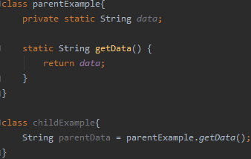

One object acquires another’s properties and behaviors. This is called a parent-child relationship, where the parent passes its properties to the child.

1. **Interface**

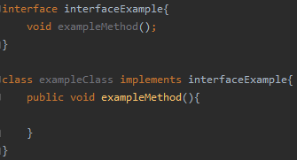

Interface is an abstract class, which groups related methods. These methods are empty and are filled when the interface is used in a class for example.

1. **Polymorphism**

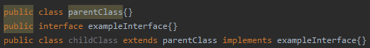

The ability of an object to take multiple forms. For example, a child object which implements an interface.

1. **Overriding**

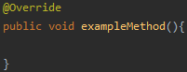

Overriding is used to provide function to inherited methods. As explained earlier, interface methods are empty, and overriding can be used to fill these methods in classes which implement the interface.

1. **Abstract classes**



Abstract classes are used to hide information from the user. These classes cannot be used to create objects and can only be accessed from an inherited class.

# Fundamental concepts

**1. What programming languages you can use for Android app development?**

-Kotlin, Java and C++

**2. What is .apk file?**

-APK = android package. It’s a file that has been compiled by SDK tools and it consists of all the code & resources of an Android app.

**3. How Android system runs apps?**

-Each app runs as their own Linux process, and the processes have their own virtual machines. The apps have their own IDs and can only access files that are assigned to that ID.

**4. Name four types of Android components. Describe each.**

-Activity: basically, what the user interacts with. Each activity does something different.

-Service: runs in the background to for example collect data or play music. It keeps the app alive even though the user doesn’t interact with it, and it doesn’t have an interface.

-Broadcast receiver: allows the app to receive system-wide notifications.

-Content provider: manages access to data. This includes sharing access to an apps data to other applications, sending data to a widget, synchronizing app data etc.

**5. What is manifest file and what is its purpose?**

-Manifest file consists of information about the application: all components, user permissions, minimum API level etc. All of these are needed so that the system to knows what to load.

**6. What are resources? Why they are needed?**

-Resources are files that are separate from the source code: images, audio, layouts, colors, animations etc. They are needed for providing different options for different configurations -> no hardcoded text for example. Helps in for example translating.